The General Manager
Date | 28-09-2014
Ref. No | FST&A/Q/R0201
Customer
.

Price Schedule
PRICE QUOTATION TO SYSTEM UPGRATING, INSTALLATION & MAINTENANCE OF
TIME ATTENDANCE UNITES ANS PAYROLL SYSTEM

Total Delivery Cost

SERIAL | ITEM DESCRIPTION | UNIT PRICE | QTY | TOTAL
NO. | ITEM DESCRIPTION | RS. |  | COST (RS.)
 | ZK HJ699 (TCP/IP) is inbuilt (2,200 Employees)  (One year warranty) | 46,000.00 | 1 | 46,000.00
 | Standard Time Attendance Software  (With Complete User Training) | 350,000.00 | 1 | 350,000.00
 | Standard Payroll Software  (With Complete User Training) | 350,000.00 | 1 | 350,000.00
 | Hardware Installations and Configurations  (Within 10m Cabling F.O.C.) | 6,500.00 | 1 | 6,500.00
Total
 | Cabling Installation (Data & Power) (With Casing, Conduits and Flexible horse) (Above 10m Cabling, we have to charge for it) | 260.00 | 1m

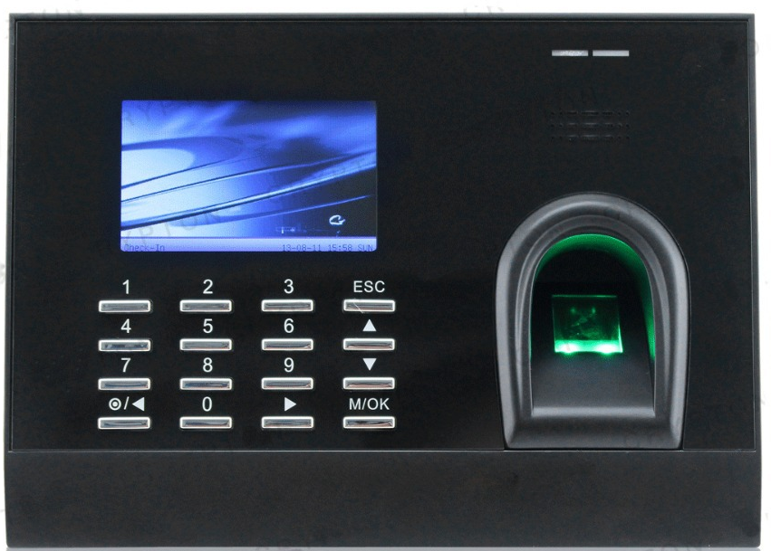



Note:
- Without Include VAT & NBT.
- Warranty Period : Comprehensive parts and labour replacement warranty for a period of 12 months ( 1 year warranty ) from the date of delivery.
*** WARRANTY COVERS ONLY MANUFACTURE'S DEFECTS. Damage of defects due to others causes such as negligence, misuse, improper operations, power fluctuations, lightening and other natural disaster, sabotage or Accidents etc are NOT included under this warranty.

- Country of Origin : China ● Supply : Ex-stock
- Validity of Offer : 30 Days ● Installation : Free of Charge
- Cabling : Rs. 260/- per meter for laying one linier meter of cable inclusive of conduits, other accessories.
- Backup : One to one backup will be provided in case of any brake down.
- Battery Backup : Available at Rs. 7, 500/- per unit. (Optional unit) (1 year warranty). Battery Backup unit working more than 6 hours without main power.
- Software : This Time & Attendance Software And Payroll Software's Standard Versions. If can be modifying your any company requirement and it's chargeable module wise.
- Delivery : On receipt of written order confirmation
- State of Equipment : Brand New and unused at the time of supply
- Protective Case : Available at Rs. 8, 500/- per unit. (Optional) (1 year warranty)
- Surge Protectors : Available at Rs. 5, 500/- per unit. (Optional unit)
(1 year warranty)
- Payments : 60% advance payment on confirmation, balance on delivery.
- Trouble Shooting : We can attend on within 72 hours (within 3 working days) all Island wide locations and sole any system issues or technical issues.
- Service Agreement : Within 1 year any services are F.O.C. After we can arrange
service agreement for each year.
If you like to accept our service agreement. Should you require any further clarifications, Please do not hesitate to contact the undersigned on 0777186375. Assuring you the best services and continuous support always.

Thanking you,
Yours faithfully,

............................................
Asanka Perera
Managing Director
Mobile 0777186375

